AT
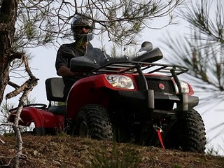
Moore's Keep
Fellowship of The Wheels

Christian Camp

11th Annual
Fellowship of The Wheels
Friday, March 5th - Saturday, March 6th, 2021

You are invited to a trail riding outing that will take place on Saturday, March 6th on the Moore’s Keep 195 acre camp land. The camp property has over 2 miles of established trails to ride and over 1 mile of water front to explore. Participants can camp overnight on the property and explore the property as they ride the main trails. The property will open on Friday, March 5th at 1:00 PM and be closed on Saturday, March 6th at 4:00 PM.

We hope you will join us for a great time of Christian fellowship as we enjoy God’s great creation while riding our fossil fuel chariots and iron horses.

All participants must be at least 18 years old or must be closely supervised by a parent or guardian. Each participant must sign a liability waver and agree to adhere to NC ATV safety laws. Parent or guardian must sign liability waver for participants under the age of 18.

This event is sponsored by Benchmark Ministries. There is no charge or registration fee required for this event. Donations will be accepted at the event to support the mission of Benchmark Ministries, a ministry dedicated to the discipleship and evangelism of young people for Jesus Christ with the Cross as our benchmark.

Individual and group registration can be made by contacting Tom Lewis or Neal Dotson of Benchmark Ministries, or Brian Lowman of South Hills Baptist Church:
Neal Dotson Tom Lewis Brian Lowman
Benchmark Ministries Benchmark Ministries South Hills Baptist Church
1200 Benchmark CT. 200 Thorn Hollow Dr. 6400 Holly Springs Road
Robbins, NC 27325 Apex, NC 27523 Raleigh, NC 27606
Phone: 919-720-2092 Phone: (919) 815-7603 Phone: (919) 859-5915
Pops@rtmc.net tomlewis@benchmarkministries.org pastor@southhillsbaptist.org

The physical address of the event is 1200 Benchmark Court. Robbins, NC 27325

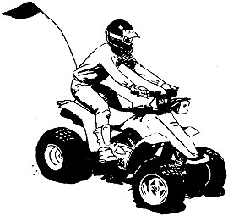
NC ATV SAFETY LAW
ATV safety bill, HB 189 was signed by the Governor Michael F. Easley on August 18, 2005 and took effect December 1, 2005.
Major provisions of the law include:
- Prohibits parent or guardian from knowingly permitting a person:
  - Under age 8 to operate an ATV;
  - Under age 12 to operate an ATV of 70 cc or greater;
  - Under age 16 to operate an ATV over 90 cc;
  - Under age 16 to operate an ATV unless under continuous visual supervision of a person at least age 18.
- Requires every ATV operator to wear eye protection and a helmet meeting U.S. DOT standards.
- Prohibits ATV operation:
- While under the influence of alcohol, any controlled substance, or a drug that impairs vision or motor coordination.
- On any public street, road, or highway except to cross or at any time on an interstate or limited-access highway.
- During the hours of darkness, without displaying a lighted headlamp and taillamp.
- Effective October 1, 2006, requires every ATV operator born on or after January 1, 1990 to possess a safety certificate indicating successful completion of an ATV safety course sponsored or approved by the All-Terrain Vehicle Safety Institute.
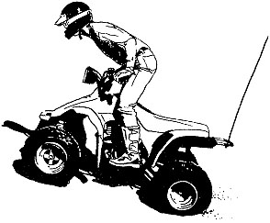
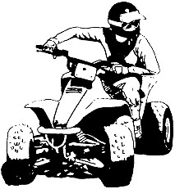
- Requires all ATVs sold or operated in the state to be equipped with a brake system, an effective muffler system and a U.S. Forest Service qualified spark arrester, all maintained in good working condition.

